# CS 255 System Design Document Justin Roberts

## UML Diagrams

### UML Use Case Diagram

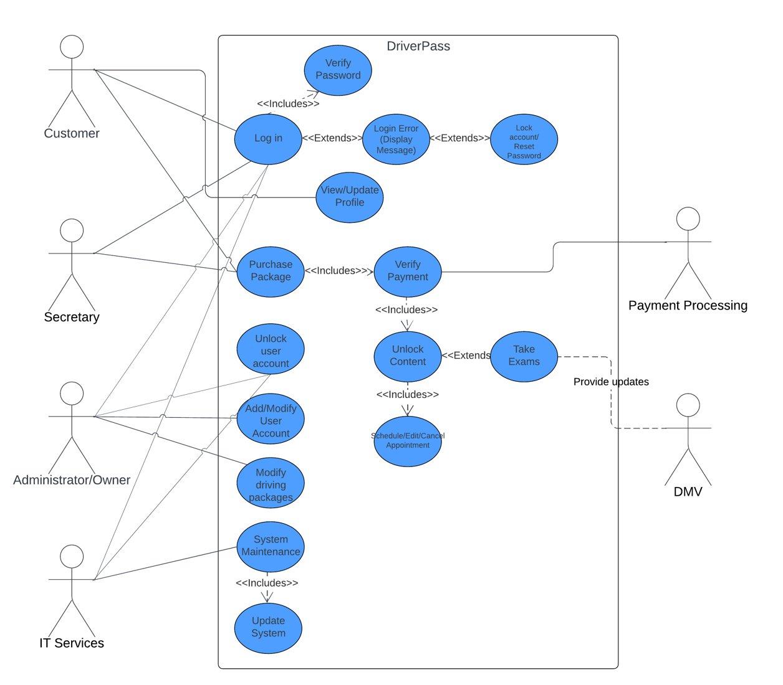

### UML Activity Diagrams

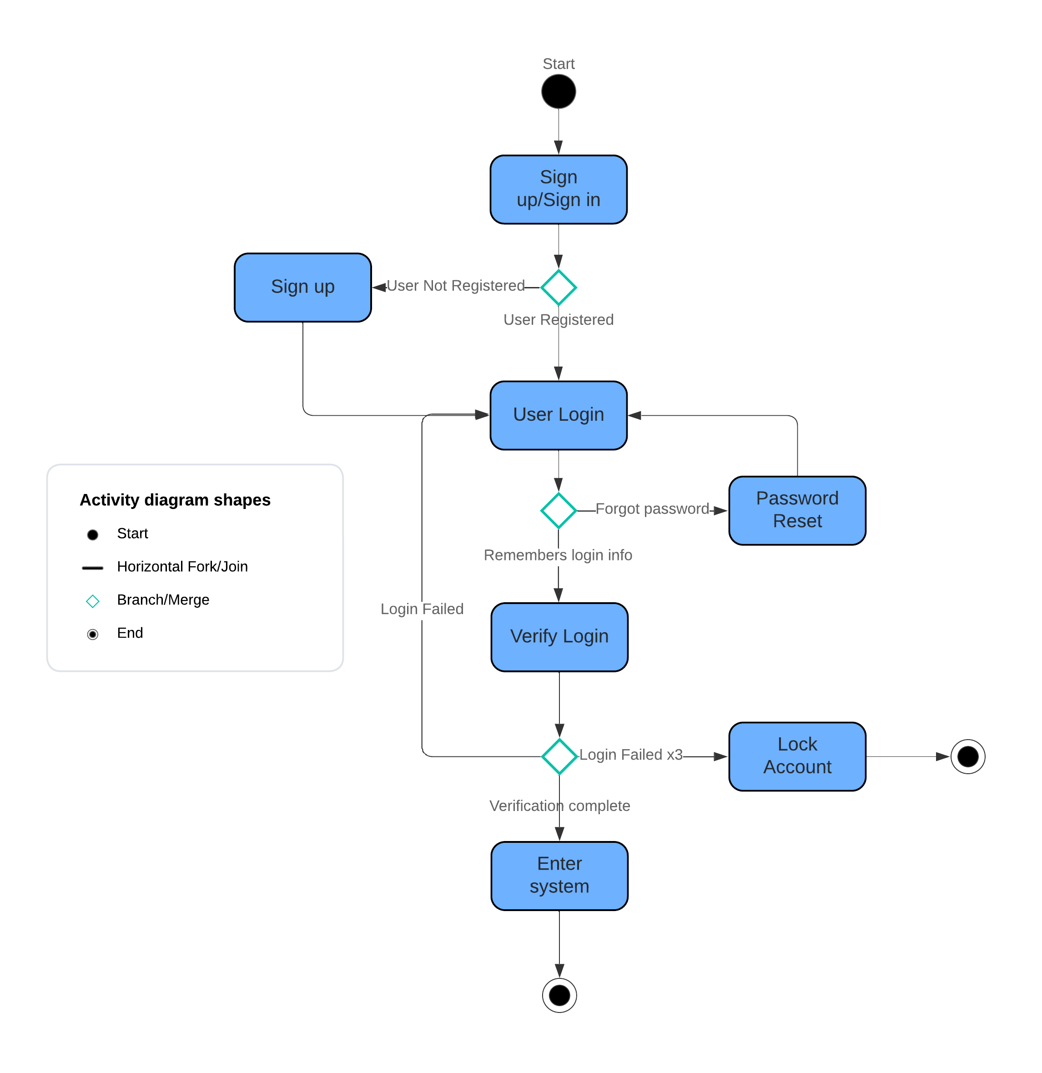

### UML Sequence Diagram

### UML Class Diagram

## Technical Requirements

* Cloud Based hosting service which includes backups and security from hosting service.
* Backend database to store user information.
* Client devices capable of running popular browser applications:
  + Laptop
  + Desktop
  + Tablet
  + Smartphone
* Internet connection
* DMV Database connection
* Platform agnostic system to support a variety of Operating Systems
* Payment Processing Integration
* IDE for programming
* Security Suite
* Vehicles for instructors